May 12th, 2015
Changes to the online Student Hire Application
1. Due to continued confusion with the Hrs/Bi-Weekly field, it has been changed to Hrs/Week. Please be sure to accurately reflect the number of hours per week the student will work. These are hours entered into Banner and are used to determine if the student employee is eligible for benefits under the Affordable Care Act.
2. Users will now select the type of action being requested: New Hire, Rehire, Hourly Rate Adjustment, Start Date Change.
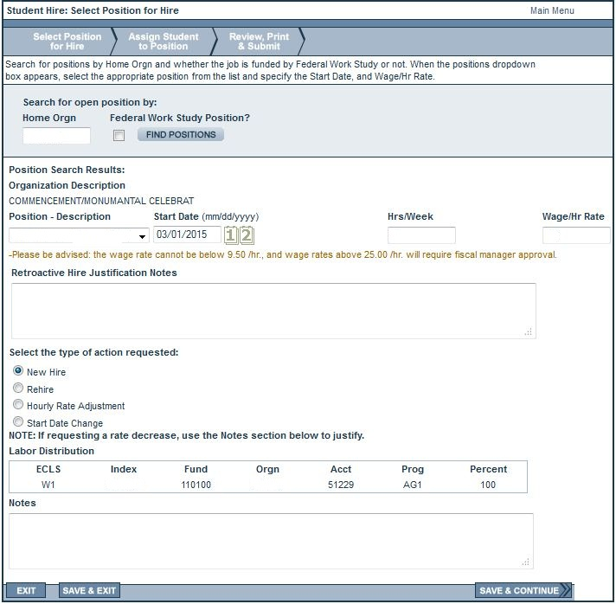
1. Hrs/Week
2. Action Requested

3. Offer Letter Attachment: An official GW Student Employee Offer Letter or Rate Increase Letter must be attached to all hires. Student Employment will reject any hires submitted without a properly completed official offer/rate increase letter. In accordance to the DC Wage Theft Presentation Amendment Act, the offer/rate increase letter must be signed and returned prior to the start date.
4. Background screening language and options have changed to properly reflect GW’s policy on background checks for all staff. There is no longer an option to select that the background screening is not required.
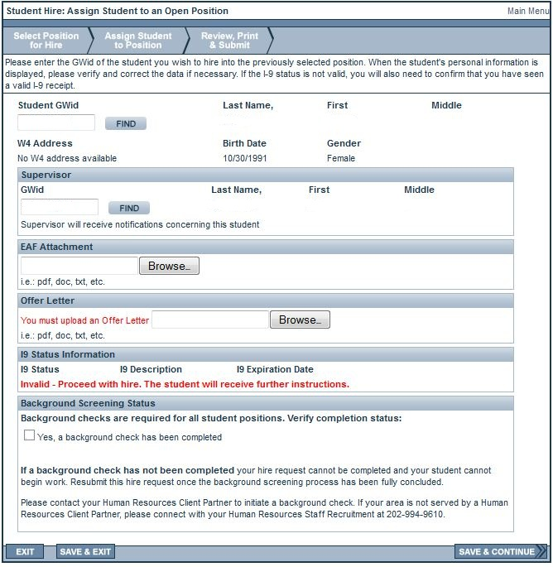
4. Background Screen Option/Info
3. Offer Letter Requirement
5. I9 Verification Email: Any hire request submitted for a student that does not have a valid I-9 form on file will continue to receive an email with instructions to complete their I-9. By law, employees must complete their I-9 within three (3) days of their start date. To help clarify this to the student the hire date will be listed in the subject line of their email.
5. Hire Date Addition
