Department Administrators use Hamilton to manage faculty internal awards/funds by tracking and assigning expenses, and requesting reimbursement from CCAS.

Reviewing a Summary of Departmental Accounts
- Click your Department in the navigation tree
- On the Overview page there are three tabs: Overview, Faculty and Transactions
  - Overview Tab provides an account summary of all active accounts, expiration dates, funding notes, original funding amounts and remaining balances. It also displays your department’s total contribution amount and balance
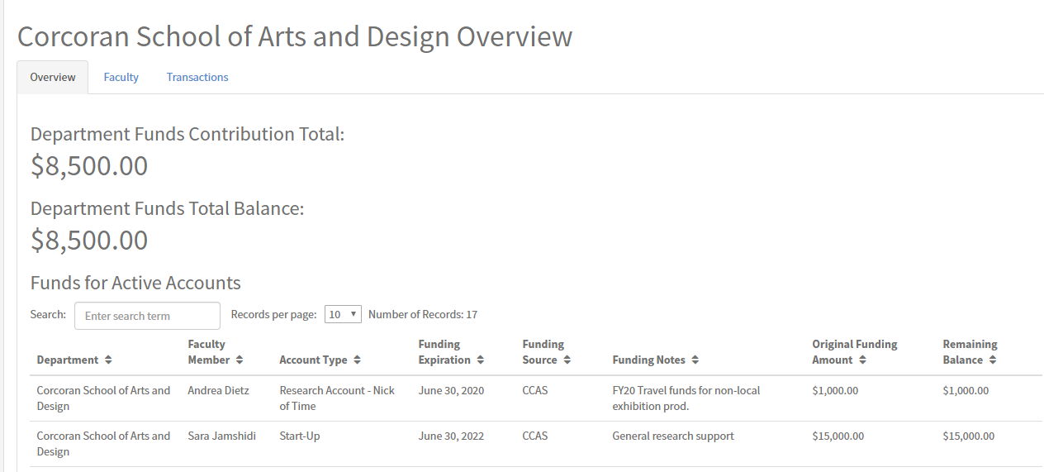
  - Faculty Tab provides a list of faculty > click on name to see a list of her/his accounts
  - Transactions tab lists transactions that have been tagged to an account but not submitted to CCAS for review. These transactions should be reviewed and either submitted or deleted

Navigating through Hamilton
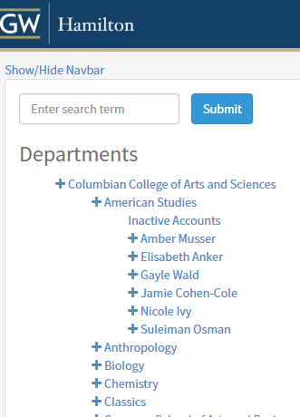
- Click Department > Faculty Member > Account
- NOTE: Click the ‘plus’ symbol next to department name and faculty name to expand the list and view more information
- On the Accounts page there are four tabs: Overview, Active Transactions, Completed Reimbursements and Department Reimbursements
  - Overview Tab provides an account summary
  - Active Transactions Tab allows you to Assign Oracle Transactions, Add Manual Transactions and see the status of active transactions
  - Completed Reimbursements Tab provides a detailed record of all approved and reimbursed transactions from CCAS
  - Department Reimbursements Tab provides a detailed record of all transactions that were covered by the Department’s commitment

Assigning Oracle EAS Transactions to a Faculty Account
- Click Department > Faculty Member > Account
  - Click the Active Transactions Tab and click Assign Oracle Transactions which leads you to a page listing Oracle expenses/transactions that have hit your departmental budget(s). Expenses from C and R-funds are loaded in Hamilton.
- Perform the following on the Untagged Oracle Transactions page:
- Adjust the start and end dates to view a time bound group of transactions
- Use the filter boxes to narrow down the list of transactions and to search for specific items
- “Tag”, or select, each transaction you want to be reimbursed
- View Inactive Transactions lists all transactions you made inactive. You have the ability to make them active again and displayed on the list of untagged oracle transactions
- Assign Transactions allows for tagged transactions to be assigned to the faculty account
- Make Inactive allows for tagged transactions to be made inactive and removed from view
- Once you have tagged the transactions you want, scroll down to end of page and click Assign Transactions, then select the Category and hit Assign/Tag.
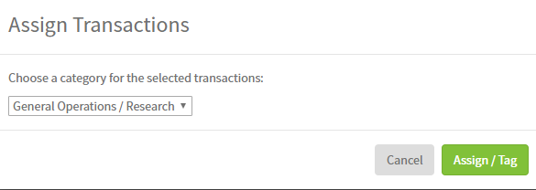
- Return to the Faculty Member’s Active Transactions Tab, select the ‘new’ transactions and Submit for Review (or Untag/Delete if you made an error or if a transaction was not approved/rejected back to you)

Creating a Manual Transaction
- Compensation charges are not loaded into Hamilton, therefore, a manual transaction must be created. You may also create a manual transaction for large capital expenditures or if an expense needs to be split between faculty members, account types or budgets
- Click Department > Faculty Member > Account
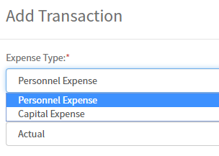
  - Click Active Transactions Tab and click Add Manual Transaction, which leads to a pop-up form that allows you to select the expense type (personnel or capital) and complete relevant information. Click Add to create.
  - Once created, return to Faculty Member’s Active Transactions Tab, select the ‘new’ transaction and Submit for Review

Need Assistance?
For Financial help: Contact the CCAS Finance Team, CCASFA@gwu.edu
For Technical support: Contact the OTS Help Desk, (202) 994-8096 or OTS@gwu.edu

